The Medical Informatics Platform is a complex information system comprising numerous software components designed and integrated by different consortium partners. In this chapter we present the logical architecture of the MIP, depicting some of its key characteristics and major building blocks. This description does not aim to be a detailed listing of all the software components produced to compose the MIP. It rather aims to assist in understanding the overall structure and interdependencies between the major services that comprise the MIP.

The following diagram Figure 1 - Overall Architecture, sketches at a very high level the overall architecture of the MIP.

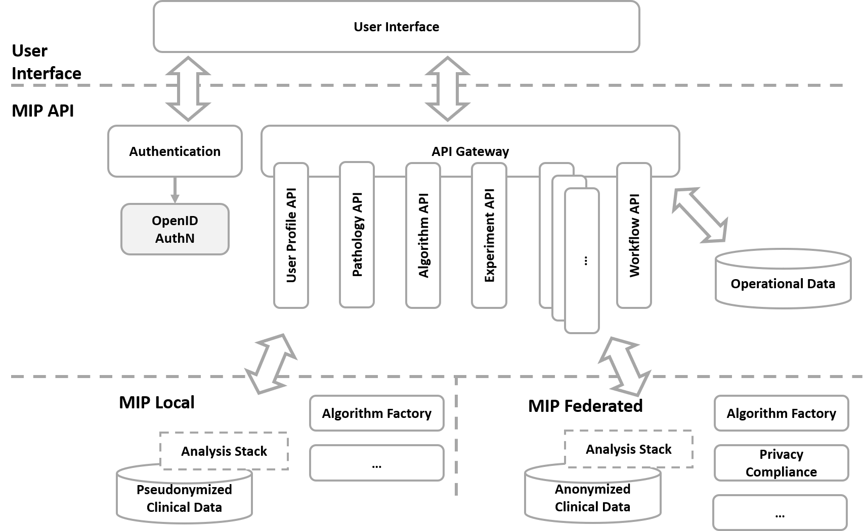

Figure 1 - Overall Architecture

The MIP is designed following an N-Tier paradigm. Multiple tiers are identified within the platform to allow for a clear separation of domains and to provide reusability and separation of concerns between the business and technology layers of the overall platform. Additionally, the various service offerings of the platform are provided following the microservice paradigm, which applies and constitutes a value adding proposition.

* The portal acts as the main entry point to the business offerings of the MIP for researchers and clinicians
* The API layer offers a protected layer of functionality exposed in a uniform and interoperable manner
* The API layer acts as a gateway to the MIP offerings, providing horizontal reuse, vertical specialization and separation of concerns and technological restrictions through the employment of a microservices architecture
* For the authentication mechanisms, proven standards are re-used to allow for a wide range of interoperability between the authenticated clients and the platform services
* A set of operational data assist in the streamlined communication and interaction between the clients and the MIP services
* The deployment stack of the MIP can be split to facilitate disjoint but complementary deployments
  + MIP Local offers enhanced services and analytical capabilities within the boundaries of each hospital
  + MIP Federated offers federated analysis over anonymized data, across multiple hospitals

**Data Management**

For more details on the various aspects of data management in the MIP, go to the Data Management Guide <https://github.com/HBPMedical/mip-docs/blob/master/MIP_Data_management_documentation.md>

The initial hospital data, including both electronic health records as well as brain scan data, go through a process of feature extraction and anonymization, before they are injected into the MIP.

* A set of Quality Control tools are utilized throughout the process to ensure the validity and compliance of the data
* Underpinning tools are utilized for the extraction of brain features as well as the mapping of the ingested data to the MIP data model
* The harmonization process builds up the canonical model that subsequent MIP operates on
* The output of the process is propagated to the subsequent MIP platform components that expose it for analysis, depending on the MIP mode of operation
  + Local analysis
  + Federated analysis

To facilitate the dual mode of operation, the MIP offers a different deployment stack so that hospitals can opt-in to the federated processing capabilities offered. The following diagram, Figure 2 - Local vs Federated Analysis, depicts the architecture and processing flow between the different modes of analysis offered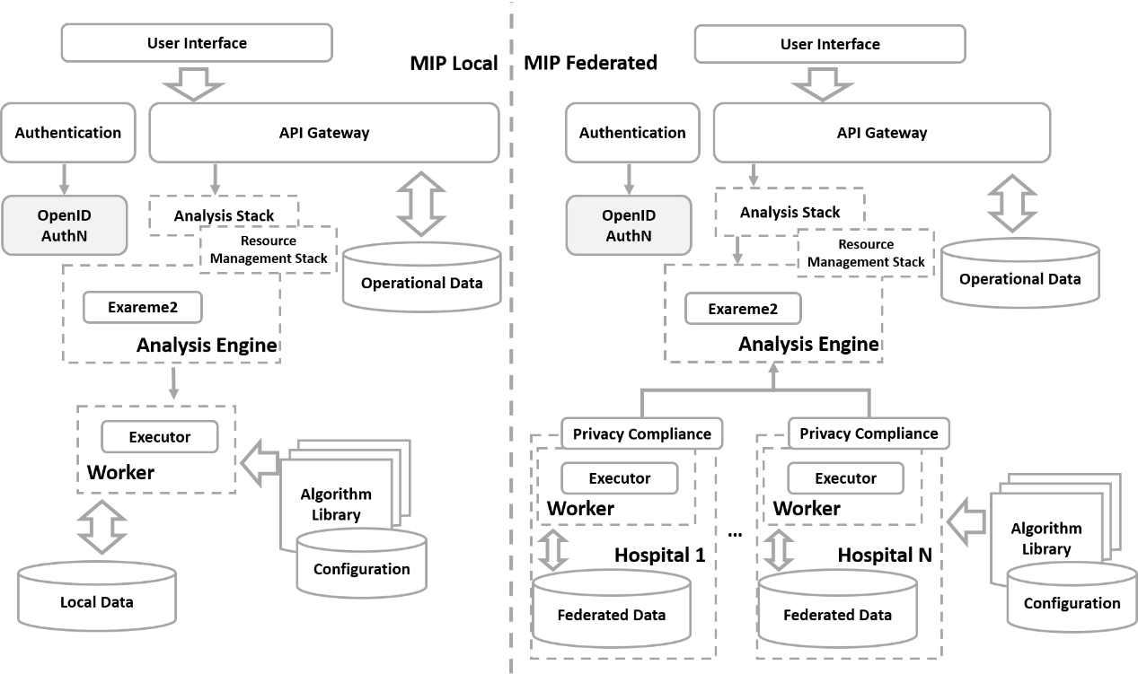

Figure 2 - Local vs Federated Analysis

Depending on the mode of operation, different hospitals may operate on a single “Local analysis” mode, or they can also participate in federation, providing their data for federated analysis.

* The analytical capabilities are offered to authenticated and authorized users of the MIP
* The API Gateway offers a uniform and homogenized handling interface to the analytical capabilities
* The User Interface presents and assists the user to perform the needed experiments
* The Analysis Stack along with the Resource Management Stack hide the complexity involved on performing the requested experiment
* The Algorithm Library offers the toolbox from which the users can select the required processing
* Depending on the mode of analysis, local or federated, the respective analysis engine will handle the appropriate communication and push the analysis within the needed boundaries
* In the case of federated analysis, the required privacy compliance will be applied at the boundaries of each contributing hospital

In the following diagram, Figure 3 - Algorithm Factory, some more details are given on the architecture and interactions between the components that underpin the analytical capabilities of the MIP.

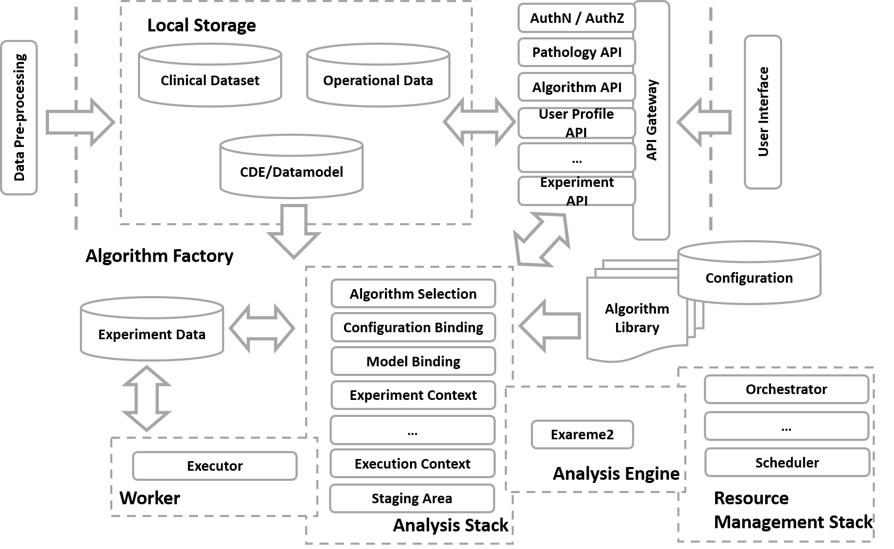

Figure 3 - Algorithm Factory

* Within each hospital, depending on the mode of analysis, local or federated, the set of available clinical data, pseudonymized (only possible in the local mode) or anonymized, are available for the analytical module to operate on
* The metadata that describe the available dataset and exposed canonical model, is used to build and evaluate the model requested
* The API Gateway interface exposes a uniform layer for interacting with the analytical flows
* The Analysis Stack contains all the required components that will assist in formulating the experiment, compose the runtime environment for its evaluation and stage its execution
* Depending on the semantics and requirements of the experiment evaluation, the appropriate analysis engine is utilized, and the needed resources are scheduled and employed
* The experiment configuration, runtime data, transient sets and results are stored within the context of the experiment

Exposing the functionality of the MIP, enhancing it through the appropriate user experience~~,~~ the MIP User Interface acts as the entry point to the MIP offerings. The following diagram, Figure 4 – User Interface, depicts the main functional areas that the MIP Portal offers and its interactions within the MIP architecture layers.

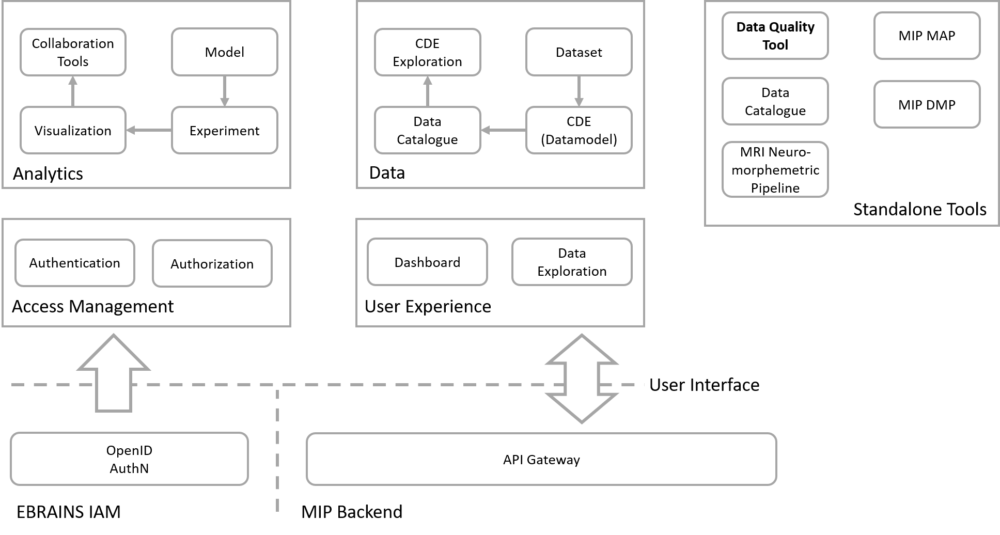

Figure 4 – User Interface

* The Analytics area is responsible to assist the user compose the model of the analysis, define the experiment to be evaluated, visualize the outcome of the analysis and define the means of collaboration through which this analysis can be further used by researchers and clinicians
* Through the Data Exploration area, the user can browse the available Datasets, define the model and schema of the data exposed by the respective datasets through the Data Catalogue, visualize the metadata available for the canonical model
* The authentication of the MIP user is performed through appropriate workflows assisted by the user interface, and the view presented to the user is tailored to the authorization the user is granted
* Additional tools can be made available to the user, e.g. the Data Quality Control Tool, used for pre-processing and preparing the data for the MIP.